**CST8253 Web Programming II**

Lab 1

# Objective

1. Install Visual Studio 2015.
2. Get familiar with Visual Studio 2015 development environment.

# Due Date

See Canvas posting for the due date of this lab. To earn 3 points, you are required:

1. Complete the lab as required.
2. Zip the solution folder (the folder containing your C# source code) and submit the zipped file to the Blackboard.
3. Demo your lab work during the following week’s lab session. 1 point penalty for failing to demo the lab work.

**Requirements**

You are going to create the C# program below to get used to the development environment in Visual Studio. Then you will make changes to see some of the errors that might occur.

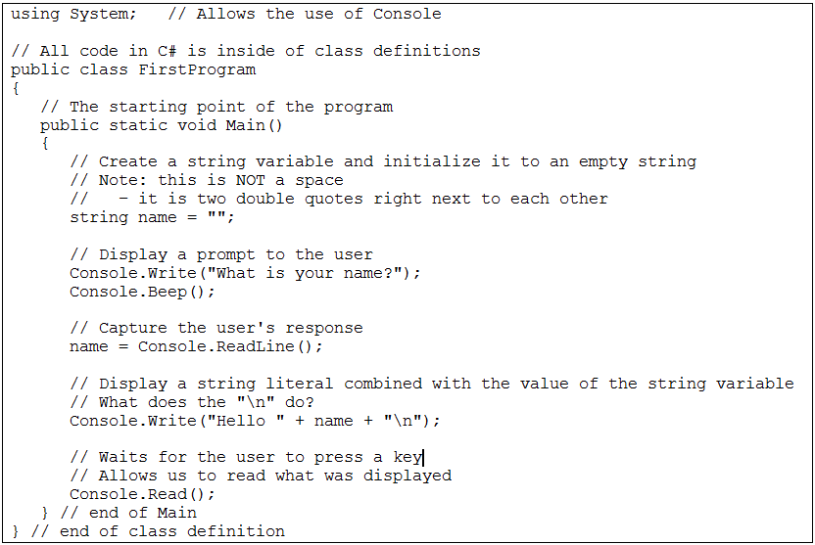

1. Download and install Visual Studio 2015.
2. Start Visual Studio.
3. Create a new project of type Windows Console Application
4. Create your first C#

* Rename the file **Program.cs** (created for you by Visual Studio) to **FirstProgram.cs**
* Open the file for editing (double click the file).
* Type in the above C# code for Main.
* (optional) Remove the extra using statements created by Visual Studio

1. Compile and run your program

* Build will report any compile error.
* Double click on each error (if any) in build report will bring you to the where the error locates in the editor window.
* Fix all errors.
* Go to the Debug menu and select “Start Debugging” to run your program.
* Test with a variety of valid and invalid inputs.

1. Introduce intentional errors to get used to test and debug with VS

Make changes as listed below to your code, **one at a time**. Recompile and run/test the program (if possible) **after each change**. Notice that if the program does not compile correctly, no new .exe is created. The .exe will still be the last successful compile.

After each change and compile attempt, return the program to its original good state before making the next change

* Remove the final *Console.Read( )*
* Remove the word *public* in both places it occurs
* Remove a semi-colon
* Change the word *string* to *int*
* Change the word *string* to *int* AND remove the = “”

* Change the word *string* to *int* AND remove the = “” AND change

*name = Console.ReadLine();*

To

*name = int.Parse(Console.ReadLine());*